TUT-3

Tutorial 3

1. What are the benefits and the disadvantages of each of the following? Consider both

the system level and the programmer level.

a. Synchronous and asynchronous communication

b. Automatic and explicit buffering

c. Send by copy and send by reference

d. Fixed-sized and variable-sized messages

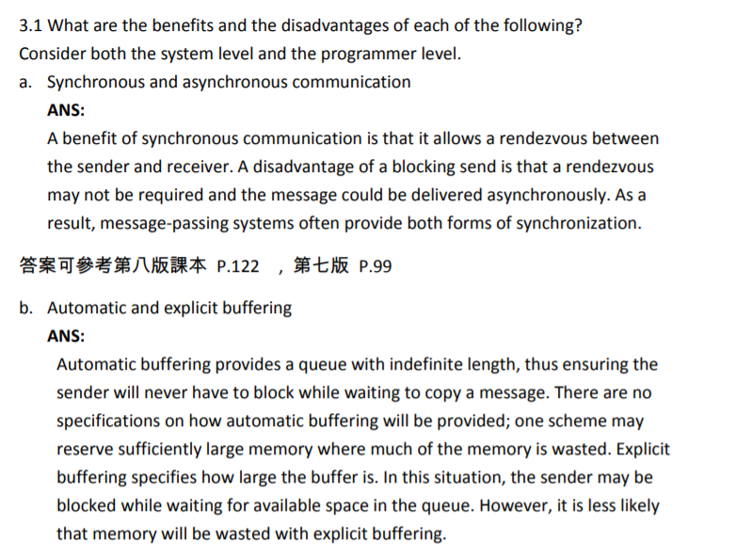

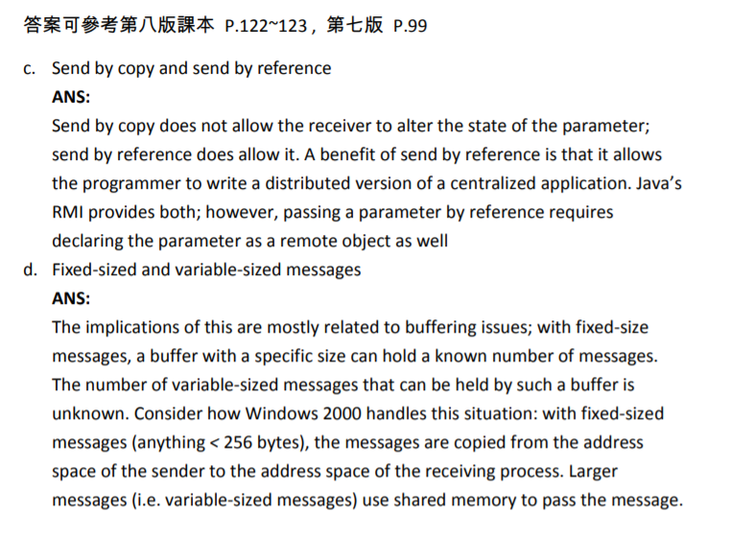

2. With respect to the RPC mechanism, consider the "exactly once" semantic. Does the

algorithm for implementing this semantic execute correctly even if the ACK message

back to the client is lost due to a network problem? Describe the sequence of

messages and discuss whether "exactly once" is still preserved.

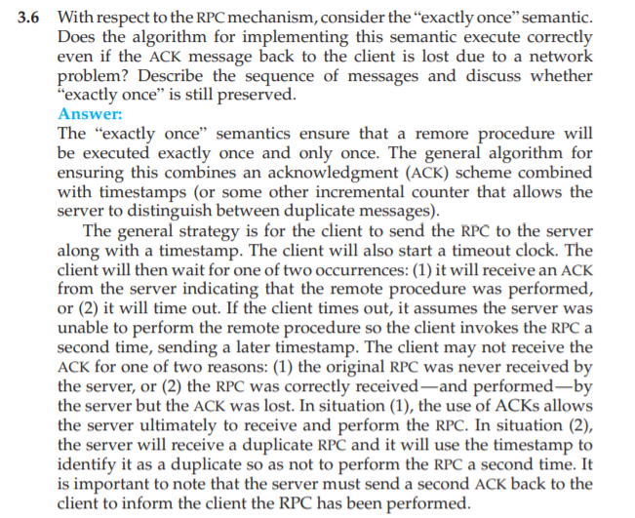

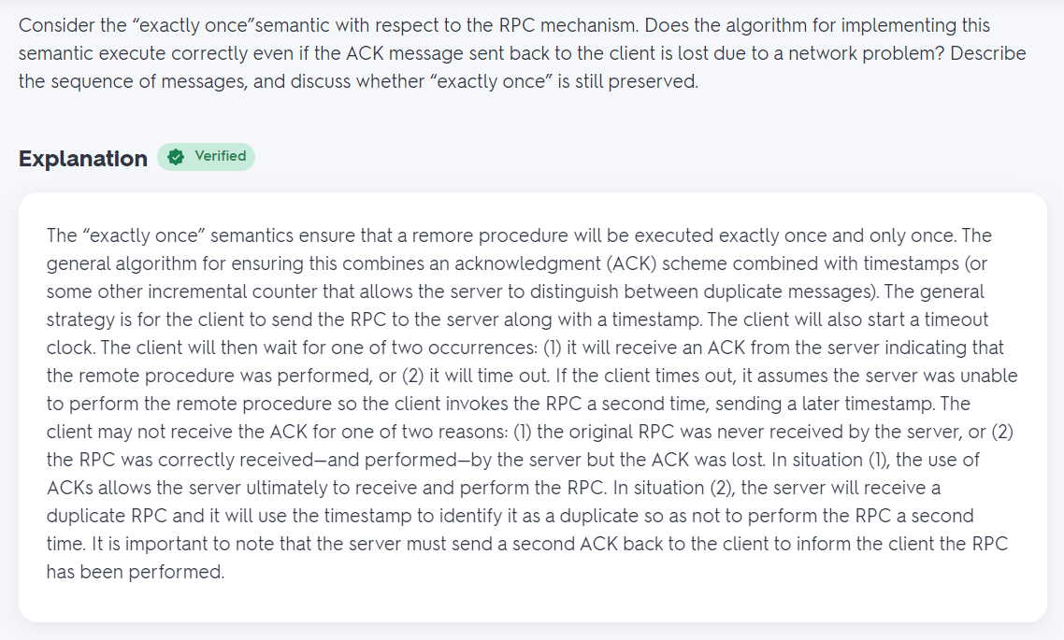

3. Palm OS provides no means of concurrent processing. Discuss three major

complications that concurrent processing adds to an operating system.

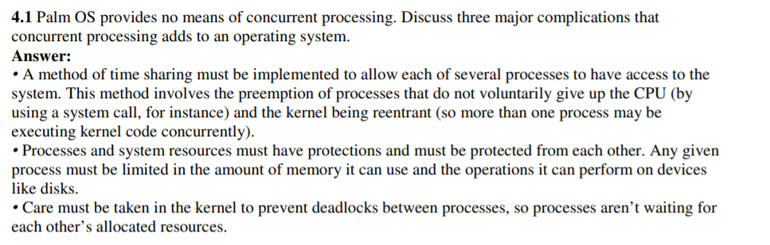

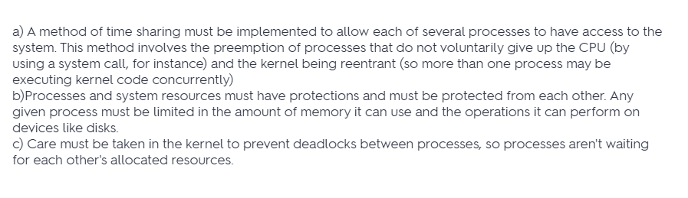

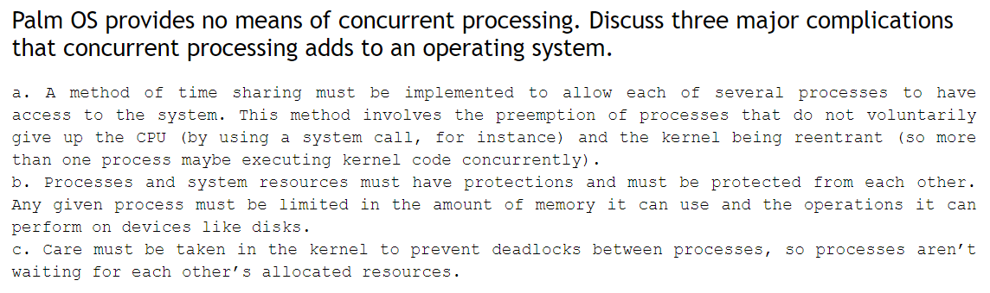

4. .

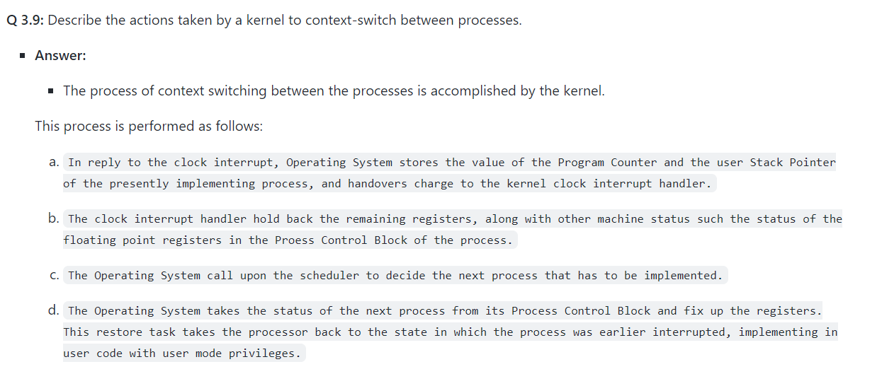

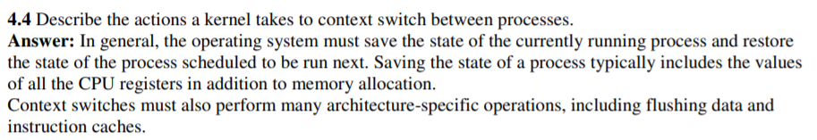

5. Including the initial parent process, how many processes are created by the following

program.

